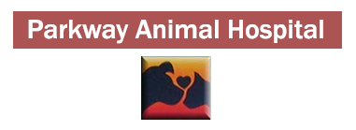 B O A R D I N G A G R E E M E N T
Pets Name_________________________________________________________________
Check-In Date_______________________Check-Out Date________________________
VACCINE POLICY:
In order to protect the health of your pet, this facility requires documentation, from a licensed veterinarian, showing that all boarding pets are current on vaccines. If vaccines need to be updated, they will be done at the time of check in at the owner’s expense.
KENNEL POLICIES:
- Flea and tick prevention is highly recommended for all pets boarding at our facility. If any external parasites are found they will be treated at owner’s expense.
- Bedding, bowls, and leashes are provided by our facility. Personal items may be left at your own risk. We are not responsible for lost or damaged items.
- Fees are charged on a per day basis, meaning you will be charged for the day of drop off as well as the day you pick up unless you arrive before 9:00 am.
Does your pet need any of the following:
- Vaccinations Grooming (See Grooming Release Form) Special Diet

- Medications *Additional $10.00 fee per day for medication administration*
Medication: ______________________________Directions:____________________________

I authorize the veterinarian to do whatever is medically/surgically necessary should an emergency arise.
I agree to pick up my pet on the above check out date. If failure to do so, a $5.00/day additional fee will be assessed.
My pet will be considered abandoned if I fail to recover my pet within 7 days past the check out date. If this happens, the pet will become property of Parkway Animal Hospital, and disposed of as deemed professionally necessary.

Siganture_______________________________________________Date:______________________

Emergency Phone Number(s):_________________________________________________________

